SWE 573 Software Development Practice, Fall 2012
Instructor: M. Ufuk Çağlayan

Project 1
RWPA-APP
Reader-Writer Process Application
Design Specifications Document

Revision 1.1
05.11.2012

By: Mustafa Göksu GÜRKAŞ
Student Id: 2011719225

Revision History

Revision | Date | Explanation
1.0 | 15.10.2012 | Initial high level design
1.1 | 05.11.2012 | Sections 2.2, 3.1.1, 3.1.2, 3.2.1.1, 3.2.2.1 and 3.3.1.1 have been updated as suggested by the client.  Section 3.3.2 and 3.3.3 have been added.

Table of Contents

Revision History 2
Table of Contents 3
Table of Figures 4
1. Introduction 5
2. System Design 5
2.1. Software Architecture 5
2.2. Software System Components 5
2.3. Environment 6
3. Detailed Design 6
3.1. Main Module/Class 6
3.1.1. Program Class 6
3.1.2. Activity Diagram 7
3.2. Other Modules/Classes 7
3.2.1. ReaderProcess Class 7
3.2.1.1. Activity Diagram 8
3.2.2. WriterProcess Class 8
3.2.2.1. Activity Diagram 9
3.3. Common Infrastructure Modules/Classes 10
3.3.1. Logger Class 10
3.3.1.1. Activity Diagram 10
3.3.2. LogRecord Class 11
3.3.3. ConfigurationRecord Class 11
4. Testing Design 12
5. References 12

Table of Figures

Figure 1. Overall Package and Classes 5
Figure 2. Class Diagram 6
Figure 3. Program Class 6
Figure 4. Activity Diagram for Program Object 7
Figure 5. ReaderProcess Class 7
Figure 6. Activity Diagram for ReaderProcess Object 8
Figure 7. WriterProcess Class 8
Figure 8. Activity Diagram for WriterProcess Object 9
Figure 9. Logger Class 10
Figure 10. Activity Diagram for Logger Object 11
Figure 11. LogRecord Class 11
Figure 12. ConfigurationRecord Class 11

1. Introduction

The purpose of this software project is to design and develop a console application by using C# as the programming language and Windows operating system as the environment, to accomplish the following main tasks.

- The user should be able to execute the program which shall create a defined number of reader and writer processes,
- Those child processes shall delay for random time intervals in order to simulate reading/writing operations from/to an imaginary shared variable,
- The actions taken by these processes shall be traceable through a log file.

The design is based on RWPA-APP Requirements Specification Document, Revision 1.1, in file Gurkas-RWPA-APP-RSD-2012-11-05-Rev-1.1.doc [1]. The design process used produce the design conforms to organizational specifications given in [2]. The notation used in this document to describe the design of RWPA Console Application is mainly UML and conforms to organizational specifications given in [3]. The ISO and TSE standards in [4], [5] and [6] are extensively used during the design.

The software architecture and overall high-level structure and components in terms of classes of RWPA Console Application are given in Section 2 and design details of all application functions and the user interface in terms of are methods of all classes are given in Section 3 of this document.

2. System Design

2.1. Software Architecture

The software to be developed shall have a multithreaded classical objects architecture model. Instead of creating new processes to handle reading and writing operations, threads will be preferred to accomplish those tasks considering the performance of the system.
Both processes and threads refer to a type of multitasking. Processes are an architectural construct where a thread is a coding construct. The main distinction is that processes have their own context (usually meaning data space), while threads have a shared context. The advantage of threads is that the CPU can switch from thread to thread without having to also change all the address context state, resulting far less usage of system resources than processes.

2.2. Software System Components

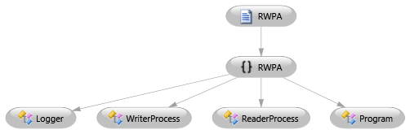
Figure 1. Overall Package and Classes

As depicted in figure 1, the system shall have only one package which is called RWPA. This package shall be composed of four classes which are;
- Program class that contains the main program,
- ReaderProcess class which shall be responsible for reading simulation,
- WriterProcess class which shall be responsible for writing simulation,
- Logger class which shall undertake the logging operations of the system.

The Program object shall initiate a number of ReaderProcess and WriterProcess objects. All of those three objects shall use Logger class in order to keep the record of their own operations through a log file. A representation of the interactions between the classes of the system is shown below.

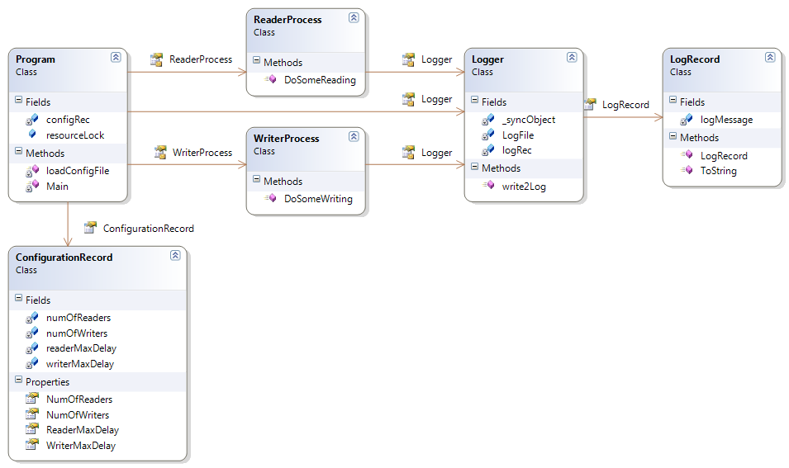
Figure 2. Class Diagram

2.3. Environment

The application shall be designed to execute on a 64-bit Windows 7 operating system with a Intel processor. The application shall be developed and tested by using Microsoft Visual Studio 2010 Ultimate (Version: 10.0.40219.1 SP1Rel). Programming language to implement the system shall be C#.

3. Detailed Design

3.1. Main Module/Class

3.1.1. Program Class

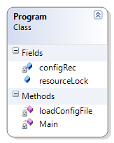
Figure 3. Program Class

Class Name: Program
Fields:
- Name: resourceLock
Type: ReaderWriterLock
Description: Static global lock object which is acquired and released by the reader/writer processes during their operations. ReaderWriterLock is used to synchronize access to a resource. At any given time, it allows either concurrent read access for multiple threads, or write access for a single thread.
- Name: configRec
Type: ConfigurationRecord
Description: A static object which encapsulates the parameters passed through configuration file.

Methods:
- Name: Main
Signature: static void Main(string[] args)
Description: Main entry point of the application.
- Name: loadConfigFile
Signature: public void loadConfigFile(string fileName)
Description: This method reads the content of a configuration file, name of which is given through its parameters and stores the values to numOfReaders, numOfWriters, readerMaxDelay and writerMaxDelay.

3.1.2. Activity Diagram

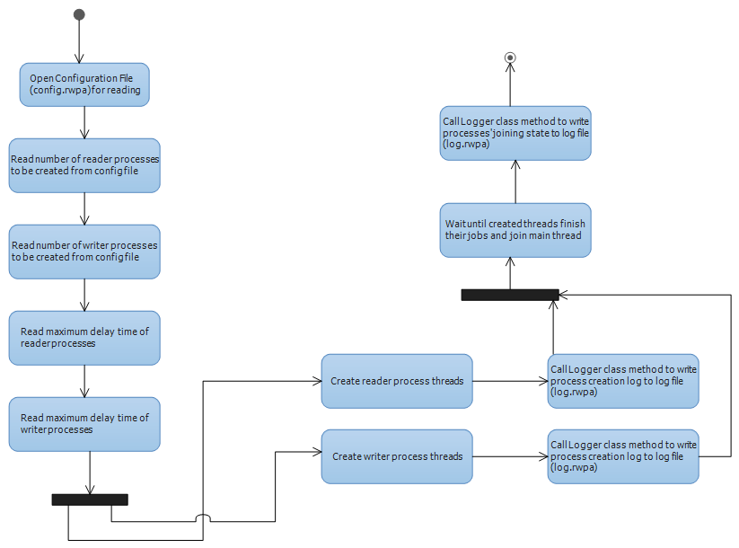
Figure 4. Activity Diagram for Program Object

3.2. Other Modules/Classes

3.2.1. ReaderProcess Class

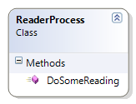
Figure 5. ReaderProcess Class

Class Name: ReaderProcess
Fields: None.
Methods:
- Name: DoSomeReading
Signature: public void DoSomeReading(object maxDelay)
Description: This method takes the maxDelay parameter to indicate a random delay in the ReaderProcess thread in order to simulate reading actions. It has an infinite loop which is used for a continuous reading action in the thread. The loop will be broken after 300 seconds (5 minutes) at most.

3.2.1.1. Activity Diagram

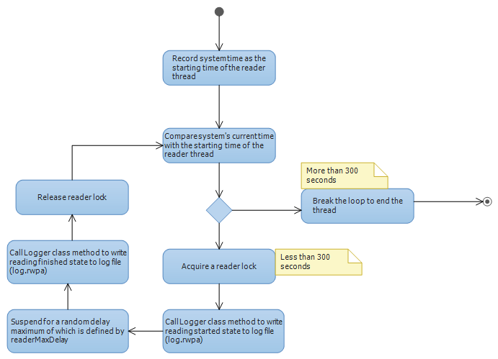

Figure 6. Activity Diagram for ReaderProcess Object

3.2.2. WriterProcess Class

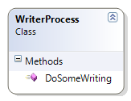
Figure 7. WriterProcess Class

Class Name: WriterProcess
Fields: None.
Methods:
- Name: DoSomeWriting
Signature: public void DoSomeWriting(object maxDelay)
Description: This method takes the maxDelay parameter to indicate a random delay in the WriterProcess thread in order to simulate writing actions. It has an infinite loop which is used for a continuous writing action in the thread. The loop will be broken after 300 seconds (5 minutes) at most.

3.2.2.1. Activity Diagram
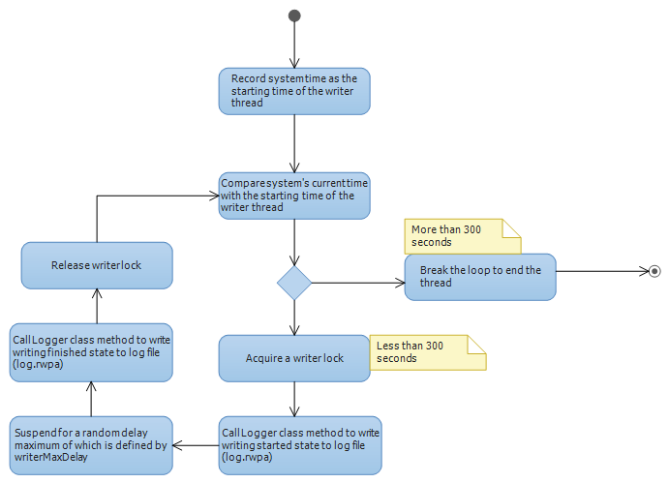

Figure 8. Activity Diagram for WriterProcess Object

3.3. Common Infrastructure Modules/Classes

3.3.1. Logger Class

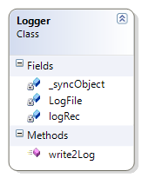
Figure 9. Logger Class
Class Name: Logger
Fields:
- Name: _syncObject
Type: object
Description: A static readonly object used to create a synchronized code area, where multiple threads will be trying to write to a shared log file.
- Name: LogFile
Type: string
Description: The name of the shared log file that threads will write their own logs.
- Name: logRec
Type: LogRecord
Description: An object which constructs and stores the formatted message to be passed to log file.

Methods:
- Name: write2Log
Signature: public static void write2Log(int threadID, string message)
Description: A static method which is used by the threads to write their actions to the shared log file. The threadId parameter is passed through the method in order to record the log demanding thread’s id into the log file. Parameter message is the plain text message of the thread to be written to log.

3.3.1.1. Activity Diagram

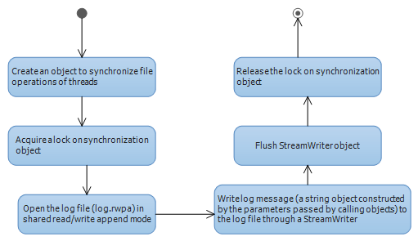

Figure 10. Activity Diagram for Logger Object

3.3.2. LogRecord Class

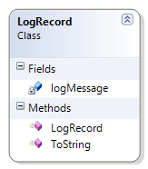
Figure 11. LogRecord Class

Class Name: LogRecord
Fields:
- Name: logMessage
Type: string
Description: A string object used to identify the message to be written in the log file.
Methods:
- Name: LogRecord
Signature: public LogRecord(int ID, string msg)
Description: Constructor method of the class which composes a formatted string to be written as log.
- Name: ToString
Signature: public override string ToString()
Description: Returns the formatted log message to the caller object.

3.3.3. ConfigurationRecord Class

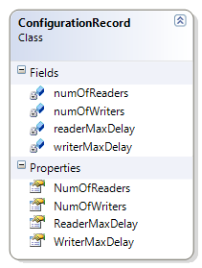
Figure 12. ConfigurationRecord Class

Class Name: ConfigurationRecord
Fields:
- Name: numOfReaders
Type: int
Description: The number of reader processes as defined in the configuration file.
- Name: numOfWriters
Type: int
Description: The number of writer processes as defined in the configuration file.
- Name: readerMaxDelay
Type: int
Description: The maximum time interval that a reader process will suspend to simulate reading operation, which shall be defined in the configuration file.
- Name: writerMaxDelay
Type: int
Description: The maximum time interval that a writer process will suspend to simulate writing operation, which shall be defined in the configuration file.
Methods:
None.

4. Testing Design

Testing and demo of the application will be completed within 5 minutes at most.

5. References

- RWPA-APP Requirements Specification Document, Rev.1.1.
- Reference to organizational design process procedure document(s), or a generic design process procedure document(s)
- Reference to organizational design product specification document(s), or a generic design product specification document(s)
- Other references to additional documents, like other internal organizational documents, software project management documents, software design tool documents, etc
- References to additional bibliographic sources, like professional books, textbooks, handbooks, patents, standards, technical reports, journal/conference papers, etc.

